Ideation Phase – Empathize & Discover

Employee Raise Issue – Empathy Map Explanation

Date | 9 September 2026
Project Name | Employee Raise Issue
Maximum Marks | 4 Marks

Purpose of the Empathy Map
The empathy map is used to understand the employee's experience when reporting workplace issues. It helps identify what employees think, feel, see, hear, say and do before and after submitting a request. These insights guide the design of a simple and employee-friendly ServiceNow solution.

User Problem
Employees may face difficulty when they do not know where to report an issue, what information to provide, or how to track the progress of a request. Manual communication can also make issue handling less organized and can lead to delays in receiving updates.

Proposed Solution
The Employee Raise Issue project provides a centralized ServiceNow Employee Center experience. A Record Producer allows employees to raise an issue using structured fields such as Requester, Category, Subcategory, State and Short Description. The submitted request can then be managed and tracked by the support team.

Key Employee Needs
The empathy map shows that employees need a quick and easy submission process, clear categories, simple instructions, proper validation, visibility of request status and timely communication. The system should reduce unnecessary manual steps and make the support process easier to understand.

Expected Benefits
The solution improves consistency in issue reporting, captures the required information in a structured format, provides better visibility of requests and supports an organized resolution process. It also creates a more convenient experience for employees through the ServiceNow portal.

Empathy Map Summary

Area | Employee Perspective
Think & Feel | Wants an easy process, timely support and clear status updates.
See | Portal, issue categories, request status and form validation.
Hear | Support instructions, progress updates and notifications.
Say & Do | Selects category, enters details, submits and tracks the  issue.
Pain | Manual steps, unclear reporting process, missing  information and delays.
Gain | Easy submission, better visibility, structured requests and faster resolution.

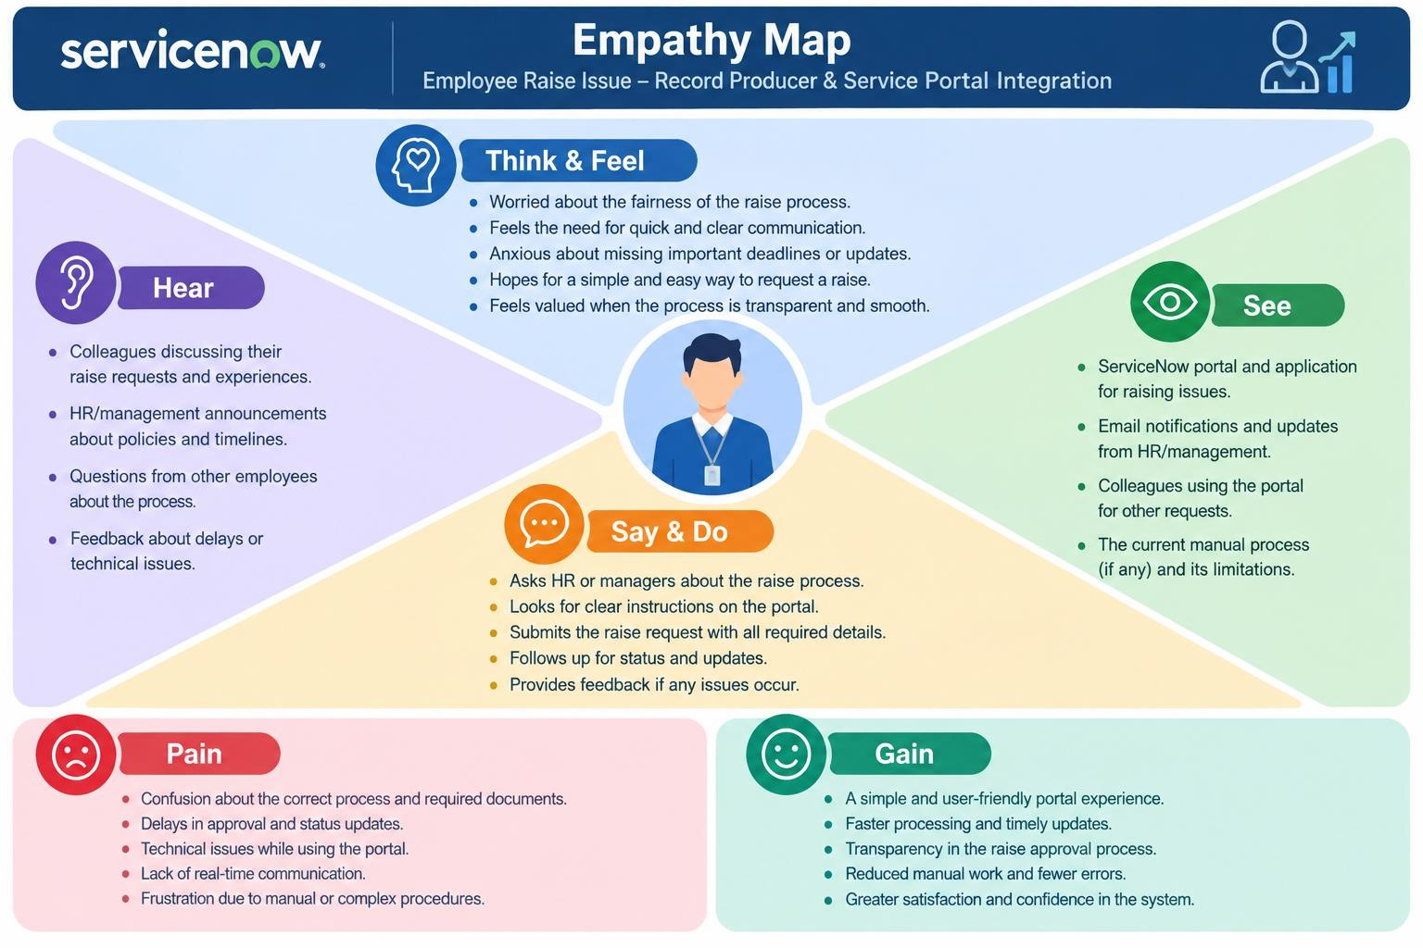

Conclusion: The empathy map helps ensure that the Employee Raise Issue solution is designed around the employee's actual needs.

